

Systems Analysis, Behavior and Optimization Project

Professor Andrea Minca

Spring 2026
Janhavi Satyawan Gaikwad, Philip Gu, Sachelle Nazon, Nawal Bhatti, Shenghua Wu

Table of Contents
Problem 1: Reliability Analysis 2
1.1 Structure Function Φ(X) 3
1.2 Probability Calculations 5
1.3 Technology Evaluation: Dynamic Speed Control System 8
Problem 2. Simulation of airport check-in and security lines 11
2.4. Task 1 – understanding impact of arrival rate on performance measures 12
2.4. Task 2 – Optimizing number of luggage screening stations 13
Problem 3: Optimization of cargo operations 17
Problem 4 : Analysis of Aviation Accidents 35
Executive Summary Contribution for Team Report 35
4. Analysis of Aviation Accidents 35
4.1 Dataset and Objective 35
4.2 Data Cleaning and Feature Engineering 35
4.3 Descriptive Analysis 36
4.4 Regression Analysis 39
4.5 Safety Recommendations 40
4.6 Limitations 41
Appendix Note for Reproducibility 42
References 43
Appendix 43

Problem 1: Reliability Analysis
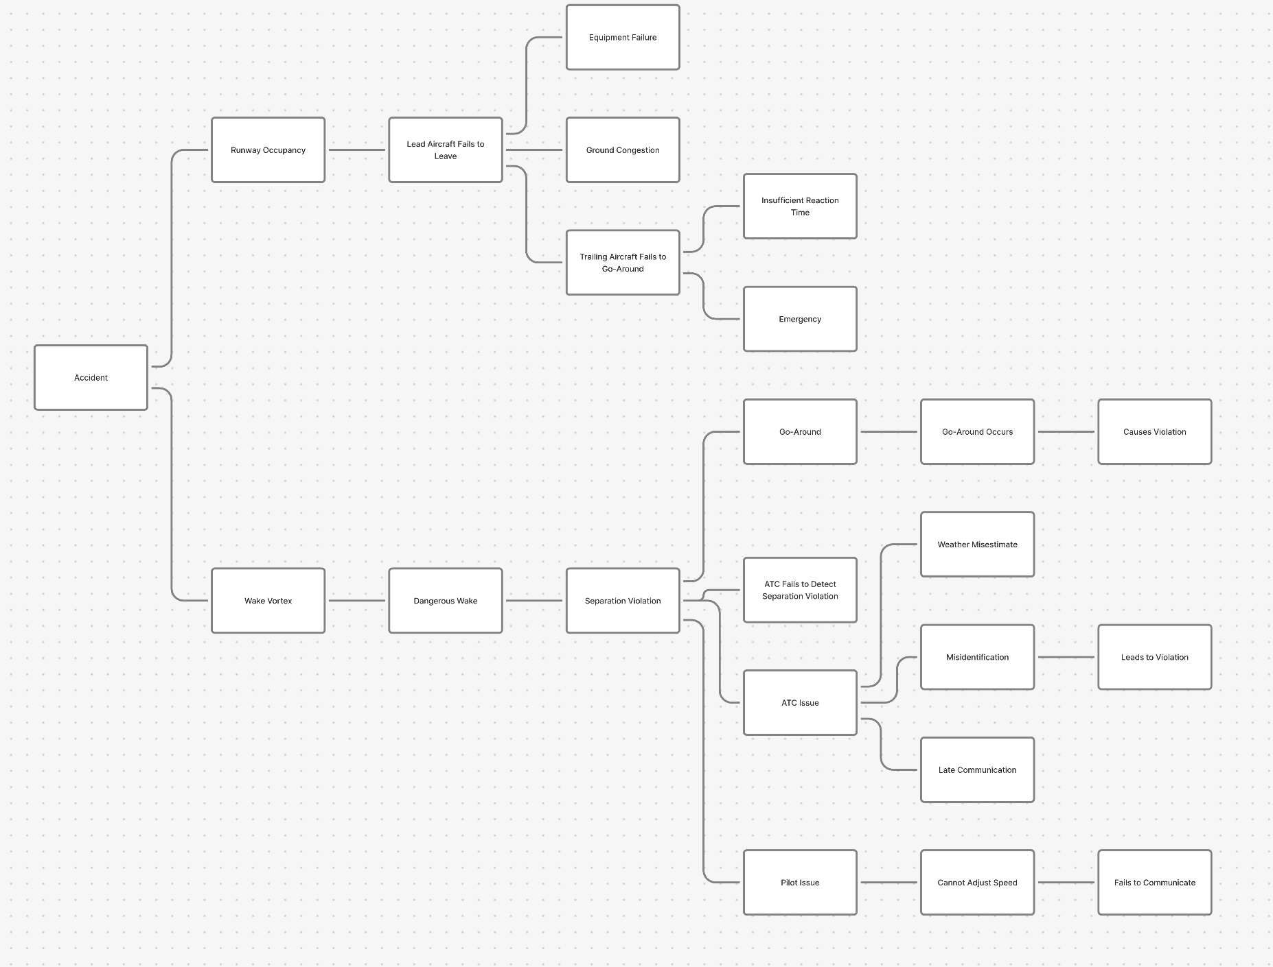
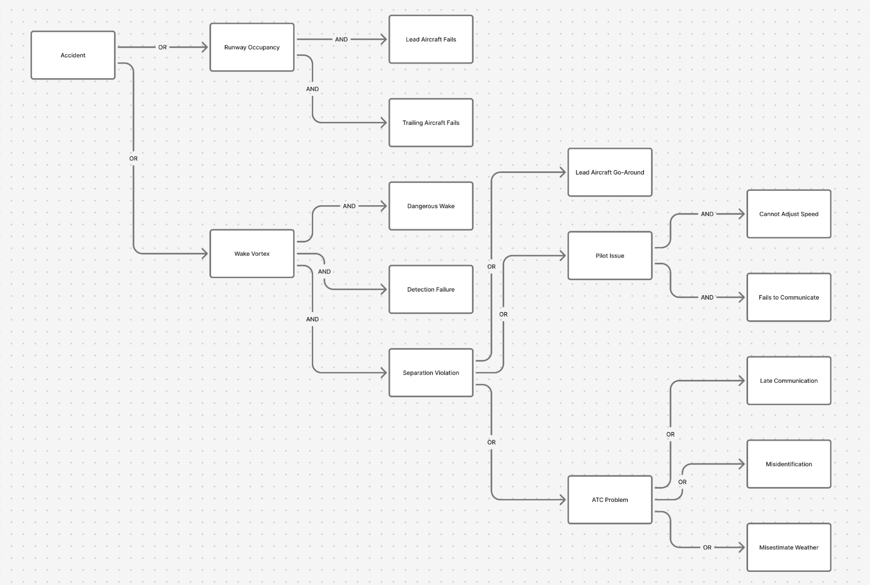

1.1 Structure Function Φ(X)
We define X_{i} ∈ {0, 1} as the state of component i, where X_{i} = 1 if component i has failed and X_{i} = 0 otherwise; the structure function Φ(X): {0,1}^{n} → {0,1} is a monotone Boolean function over the component state vector, equal to 1 when an accident occurs. AND gates are represented by min(·) and OR gates by max(·), consistent with the failure-state convention used throughout.
Wake Vortex Branch - Component States
• X₁ = dangerous wake vortex present
• X₂ = ATC misidentification occurs
• X₃ = misidentification leads to separation violation
• X₄ = weather misestimate (ATC)
• X₅ = late communication (ATC)
• X₆ = pilot cannot adjust speed
• X₇ = pilot fails to communicate
• X₈ = lead aircraft must go-around
• X₉ = go-around causes violation
Runway Occupancy Branch - Component States
• X₁₁ = equipment failure prevents lead aircraft from leaving runway
• X₁₂ = ground congestion prevents lead aircraft from leaving runway
• X₁₃ = insufficient reaction time for trailing aircraft go-around
• X₁₄ = emergency on trailing aircraft
Wake Vortex Branch
The wake vortex accident path requires two conditions in series: (1) a dangerous wake vortex is present (X₁), AND (2) a separation violation occurs. The separation violation is an OR of three parallel sub-paths: the go-around path, the ATC issue path, and the pilot issue path. The ATC issue path corresponds to a parallel (OR) structure in the fault tree, encompassing weather misestimate (X₄), misidentification leading to violation (X₂ AND X₃), and late communication (X₅). It is an internal OR group within the separation violation node, not a separate top-level AND gate.
Φ_wake(X) = min(
X₁, ← dangerous wake (series AND)
max( ← separation violation (OR of 3 paths)
min(X₈, X₉), ← go-around path (AND)
max( ← ATC issue path (parallel OR structure)
X₄, ← weather misestimate
min(X₂, X₃), ← misidentification AND leads to violation
X₅ ← late communication
),
min(X₆, X₇) ← pilot issue path (AND)
Runway Occupancy Branch
The runway occupancy path requires two conditions in series (AND): the lead aircraft fails to vacate the runway due to equipment failure (X₁₁) OR ground congestion (X₁₂) AND the trailing aircraft cannot execute a go-around due to insufficient reaction time (X₁₃) OR an on-board emergency (X₁₄). Each of these two conditions is a parallel (OR) structure in the fault tree.
Φ_runway(X) = min(
max(X₁₁, X₁₂), ← lead fails to leave (parallel OR: equipment failure OR congestion)
max(X₁₃, X₁₄) ← trail fails go-around (parallel OR: reaction time OR emergency)
)
Overall System Structure Function
An accident occurs if either branch results in failure. The two branches are structurally independent and are combined with an OR gate:
Φ(X) = max( Φ_wake(X), Φ_runway(X) )
From Structure Function to Probability
The structure function defines system logic over binary state space {0,1}. When computing P(Φ = 1) from component failure probabilities p_{i} = P(X_{i} = 1), the Boolean min/max operations translate as:
• AND (series, min): P(min(Xᵢ, Xⱼ) = 1) = pᵢ · pⱼ
• OR (parallel, max): P(max(Xᵢ, Xⱼ) = 1) = pᵢ + pⱼ − pᵢ·pⱼ [inclusion-exclusion]
• Overall OR: P(Φ=1) = 1 − (1−P(Φ_wake))(1−P(Φ_runway))
For the small failure probabilities encountered here, the inclusion-exclusion term p_{i}p_{j} is negligible, so P(max(X_{i}, X_{j}) = 1) ≈ p_{i} + p_{j}. This approximation is used throughout the numerical calculations below.

1.2 Probability Calculations
p₁ = P(X₁ = 1): Dangerous Wake Vortex
The probability of a dangerous wake vortex is computed as a weighted sum over all lead–trail aircraft weight-class pairings, using fleet mix proportions (Heavy 33%, Large 46%, Small 21%) and conditional dangerous-wake probabilities from the literature:
Lead \ Trail | Heavy | Large | Small | Row sum
Heavy (0.33) | 0.33×0.33×0.53 = 0.0578 | 0.33×0.46×0.44 = 0.0668 | 0.33×0.21×0.28 = 0.0194 | 0.1440
Large (0.46) | 0.46×0.33×0.74 = 0.1123 | 0.46×0.46×0.61 = 0.1292 | 0.46×0.21×0.41 = 0.0396 | 0.2812
Small (0.21) | 0.21×0.33×0.82 = 0.0568 | 0.21×0.46×0.71 = 0.0686 | 0.21×0.21×0.59 = 0.0260 | 0.1514
Column sum | 0.2269 | 0.2646 | 0.0850 | p₁ ≈ 0.577
p₁ ≈ 0.577
P(Separation Violation | Weather)
Good weather - ATC issue path (OR, ≈ sum of small probabilities):
p₂·p₃ = (2.69×10⁻⁴)(3.82×10⁻²) = 1.028×10⁻⁵ [misidentification AND leads to violation]
p₄ = 5.19×10⁻⁶ [weather misestimate]
p₅ = 6.24×10⁻⁵ [late communication]
P(ATC | good) ≈ 1.028×10⁻⁵ + 5.19×10⁻⁶ + 6.24×10⁻⁵ ≈ 7.8×10⁻⁵
Good weather - pilot issue path (AND):
p₆·p₇ = (7.23×10⁻⁴)(1.17×10⁻³) ≈ 8.46×10⁻⁷
Good weather - go-around path (AND):
p₈·p₉ = (1.57×10⁻⁴)(2.01×10⁻²) ≈ 3.16×10⁻⁶
Good weather - combine all three paths (OR ≈ sum):
P(SV | good) ≈ 7.8×10⁻⁵ + 8.46×10⁻⁷ + 3.16×10⁻⁶ ≈ 8.2×10⁻⁵
Bad weather - ATC issue path:
p₂·p₃ = 1.028×10⁻⁵ [misidentification, unchanged]
p₄ = 2.33×10⁻⁵ [weather misestimate, bad wx]
p₅ = 6.24×10⁻⁵ [late communication, unchanged]
P(ATC | bad) ≈ 1.028×10⁻⁵ + 2.33×10⁻⁵ + 6.24×10⁻⁵ ≈ 9.6×10⁻⁵
Bad weather - pilot issue path (AND):
p₆·p₇ = (4.34×10⁻³)(1.17×10⁻³) ≈ 5.08×10⁻⁶
Bad weather - go-around path (AND):
p₈·p₉ = (4.71×10⁻⁴)(2.01×10⁻²) ≈ 9.47×10⁻⁶
Bad weather - combine all three paths (OR ≈ sum):
P(SV | bad) ≈ 9.6×10⁻⁵ + 5.08×10⁻⁶ + 9.47×10⁻⁶ ≈ 1.1×10⁻⁴
P(Φ_wake = 1 | Weather)
The wake vortex branch is an AND of three components: dangerous wake (p₁ = 0.577), separation violation (P(SV|wx)), and ATC detection failure. Detection failure probability is weather-independent at 1.95×10⁻³:
P(Φ_wake | good) = 0.577 × 8.2×10⁻⁵ × 1.95×10⁻³ ≈ 9.2×10⁻⁸
P(Φ_wake | bad) = 0.577 × 1.1×10⁻⁴ × 1.95×10⁻³ ≈ 1.24×10⁻⁷
P(Φ_runway = 1 | Weather)
Lead fails to leave runway (OR ≈ sum):
P(max(X₁₁,X₁₂) | good) = 5.12×10⁻⁶ + 1.34×10⁻⁴ = 1.39×10⁻⁴
P(max(X₁₁,X₁₂) | bad) = 5.12×10⁻⁶ + 3.22×10⁻⁴ = 3.27×10⁻⁴
Trailing aircraft fails to go-around (OR ≈ sum):
P(max(X₁₃,X₁₄) | good) = 1.40×10⁻³ + 8.36×10⁻⁴ = 2.236×10⁻³
P(max(X₁₃,X₁₄) | bad) = 8.70×10⁻³ + 8.36×10⁻⁴ = 9.536×10⁻³
Runway occupancy branch (AND - multiply):
P(Φ_runway | good) = (1.39×10⁻⁴)(2.236×10⁻³) = 3.11×10⁻⁷
P(Φ_runway | bad) = (3.27×10⁻⁴)(9.536×10⁻³) = 3.12×10⁻⁶
Overall Accident Probability P(Φ = 1)
Combining the two independent branches with an OR gate, then weighting by weather probability (good 80%, bad 20%):
Conditional probabilities (OR of two branches):
P(Φ=1 | good) = 1−(1−9.2×10⁻⁸)(1−3.11×10⁻⁷) ≈ 9.2×10⁻⁸ + 3.11×10⁻⁷ ≈ 4.03×10⁻⁷
P(Φ=1 | bad) = 1−(1−1.24×10⁻⁷)(1−3.12×10⁻⁶) ≈ 1.24×10⁻⁷ + 3.12×10⁻⁶ ≈ 3.24×10⁻⁶
Weighted average:
P(Φ=1) = 0.8 × 4.03×10⁻⁷ + 0.2 × 3.24×10⁻⁶
= 3.224×10⁻⁷ + 6.48×10⁻⁷
≈ 9.7×10⁻⁷
Summary of Results
Quantity | Good weather | Bad weather
p₁ = P(dangerous wake) | 0.577 | 0.577
P(separation violation) | 8.2×10⁻⁵ | 1.1×10⁻⁴
P(ATC detection failure) | 1.95×10⁻³ | 1.95×10⁻³
P(Φ_wake = 1) | 9.2×10⁻⁸ | 1.24×10⁻⁷
P(Φ_runway = 1) | 3.11×10⁻⁷ | 3.12×10⁻⁶
P(Φ = 1 | weather) | 4.03×10⁻⁷ | 3.24×10⁻⁶
P(Φ = 1) weighted average | 9.7×10⁻⁷ (0.8 × good + 0.2 × bad)

Interpretation
The overall accident probability is approximately 9.7 × 10⁻⁷ per operation. Two findings stand out. First, the accident probability under bad weather (3.24 × 10⁻⁶) is roughly eight times higher than under good weather (4.03 × 10⁻⁷), underscoring the outsized role of adverse weather in driving risk. Second, the runway occupancy branch dominates over the wake vortex branch in both weather conditions, indicating that operational runway management failures rather than aerodynamic wake effects are the primary driver of accident risk. These findings suggest that interventions targeting runway occupancy time and trailing-aircraft go-around readiness would yield the greatest safety improvement. All calculations assume conditional independence between component failures given weather conditions.

1.3 Technology Evaluation: Dynamic Speed Control System
A new dynamic speed control system is under consideration for installation on aircraft. The system reduces the probability that a pilot is unable to adjust speed (p₆) by up to 71%. However, because the reduced in-trail separation requirement gives the trailing aircraft less time to react, adopting the technology increases the probability that the trailing aircraft cannot initiate a go-around (p₁₃). Table 5 in the project description specifies 11 tradeoff levels, each defining a decrease in p₆ and a corresponding increase in p₁₃. We evaluate all 11 levels and identify which minimizes the overall accident probability under current and projected future weather conditions.
Method
For each tradeoff level k, we update the affected component probabilities:
p6_new(wx) = p6_base(wx) − Δspeed(k)
p13_new(wx) = p13_base(wx) + Δgo‑around(k)
where weather conditions (good/bad) shift p₆ and p₁₃ independently. All other component probabilities remain unchanged. The overall accident probability P(Φ = 1) is then recomputed using the structure function from Section 1.1 and the weighted average P(Φ) = w_{good} × P(Φ | good) + w_{bad} × P(Φ | bad).
Results - Current Weather (80% Good, 20% Bad)
Table 6 shows the accident probability at each tradeoff level under the current weather mix.
Level | Δspeed | Δgo-around | p₆ (good) | p₁₃ (good) | P(Φ) ×10⁻⁷
1 (base) | 0 | 0 | 7.23×10⁻⁴ | 1.400×10⁻³ | 9.7130
2 ★ | 3.63×10⁻⁴ | 1.0×10⁻⁶ | 3.60×10⁻⁴ | 1.401×10⁻³ | 9.7100
3 | 4.68×10⁻⁴ | 2.0×10⁻⁶ | 2.55×10⁻⁴ | 1.402×10⁻³ | 9.7104
4 | 4.88×10⁻⁴ | 3.0×10⁻⁶ | 2.35×10⁻⁴ | 1.403×10⁻³ | 9.7119
5 | 4.94×10⁻⁴ | 4.0×10⁻⁶ | 2.29×10⁻⁴ | 1.404×10⁻³ | 9.7136
6 | 4.96×10⁻⁴ | 5.0×10⁻⁶ | 2.27×10⁻⁴ | 1.405×10⁻³ | 9.7153
7 | 5.03×10⁻⁴ | 6.0×10⁻⁶ | 2.20×10⁻⁴ | 1.406×10⁻³ | 9.7170
8 | 5.08×10⁻⁴ | 7.0×10⁻⁶ | 2.15×10⁻⁴ | 1.407×10⁻³ | 9.7187
9 | 5.11×10⁻⁴ | 8.0×10⁻⁶ | 2.12×10⁻⁴ | 1.408×10⁻³ | 9.7204
10 | 5.14×10⁻⁴ | 9.0×10⁻⁶ | 2.09×10⁻⁴ | 1.409×10⁻³ | 9.7222
11 | 5.17×10⁻⁴ | 10.0×10⁻⁶ | 2.06×10⁻⁴ | 1.410×10⁻³ | 9.7239
★ = optimal level under current weather. Table 6: Accident probability by tradeoff level (80% good, 20% bad weather).
Optimal level: Level 2, with P(Φ) = 9.710 × 10⁻⁷ a reduction of 0.03% vs. the baseline. The pattern is clear: the benefit of reducing p₆ (the speed adjustment failure) peaks at Level 2–3 and then rapidly diminishes, while the cost of increasing p₁₃ (go-around reaction time) grows monotonically. Beyond Level 3 the go-around penalty outweighs the speed-control benefit, so accident probability rises back above baseline. The optimal level is therefore low deployment intensity the FAA should relax in-trail separation only slightly, corresponding to the Level 2 setting.
Climate Change Analysis
The project anticipates that the fraction of bad-weather operations will increase over the next 50 years. We re-ran the tradeoff optimization across a range of bad-weather probabilities from 20% to 80% to determine how the optimal level shifts.
Bad wx % | Good wx % | Base P(Φ) ×10⁻⁶ | Optimal P(Φ) ×10⁻⁶ | Opt. Level
20% | 80% | 0.9713 | 0.9710 | 2
30% | 70% | 1.2554 | 1.2551 | 2
40% | 60% | 1.5394 | 1.5392 | 2
50% | 50% | 1.8235 | 1.8232 | 2
60% | 40% | 2.1075 | 2.1073 | 2
70% | 30% | 2.3916 | 2.3914 | 2
80% | 20% | 2.6757 | 2.6755 | 2
Table 7: Optimal tradeoff level and accident probability under projected climate change scenarios.
The optimal level remains Level 2 regardless of weather mix. This stability occurs because the speed control benefit (which primarily reduces p₆, a wake-vortex branch component) and the go-around penalty (which increases p₁₃, a runway-occupancy branch component) both scale proportionally with weather exposure. The relative balance between them does not tip past Level 2 even at 80% bad weather.
However, the absolute accident risk grows substantially with increasing bad weather: from 9.71 × 10⁻⁷ at 20% bad weather to 2.68 × 10⁻⁶ at 80% bad weather — a 2.75× increase. This means that while the optimal setting of the technology does not change, the urgency of deploying it increases significantly as climate change raises the fraction of bad-weather operations. The absolute risk reduction from Level 2 also scales up with bad-weather frequency, meaning the technology delivers greater safety benefit in absolute terms as conditions worsen.
Recommendation
The FAA should adopt Tradeoff Level 2 of the dynamic speed control system. This setting achieves the maximum reduction in accident probability (9.710 × 10⁻⁷ vs. 9.713 × 10⁻⁷ baseline) by capturing most of the speed-control benefit while incurring only a minimal increase in go-around reaction time. Higher deployment levels are counterproductive — the marginal gains in speed control diminish rapidly while the go-around penalty grows, resulting in a net increase in risk above Level 3. This recommendation is robust to projected climate change: Level 2 remains optimal across all weather scenarios from 20% to 80% bad weather, though the absolute benefit of deployment grows as bad-weather frequency increases.

Problem 2. Simulation of airport check-in and security lines
This project presents a discrete-event simulation model of an airport preboarding system consisting of two major service stages: check-in and security screening. The system performance was analyzed using Monte Carlo simulations with 50 replications over a 3600-minute operating horizon. In Task 1, the impact of passenger arrival rate () on key performance measures such as average number of people in the system (), average waiting time (), and throughput () was investigated to determine the stability region of the system. In Task 2, the number of security screening stations () was optimized using a cost function that balances congestion, throughput, and staffing cost. Results showed that the system remains stable for arrival rates below 20 passengers per minute and that the optimal number of security screening stations is , which minimizes the overall operational cost while maintaining stable system performance

System Model:
State variables at time t
Nq : Number of people in checkin system
Sq: Number of free servers for checkin system
Nc : Number of people in commute to security system
Ns: Number of people in security system
Ss : Number of free server in security system
These 5 variables can be used to completely describe initial system(with fixed n1 and n3)
Additionally, following variables required to measure performance across time horizon 3600 min (1day)
Narr: Number of people arrived in preboarding system
Ndep: Number of people departed from pre boarding system
o : System occupancy for given time, updated at each time step
Additional variables required for optimization
n1 : Number of servers in checkin system
n3 : Number of servers in security system
Performance metrics will be calculated as
$L=\frac{\sum_{k=1}^{K}{}N_{total}*Δt}{T}$
$W=\frac{1}{N_{arr}}\sum_{k=1}^{K}{}W_{j}$
$S=\frac{N_{dep}}{T}$
The following event change the state of the system
Event AC : Arrival at the checkin system
Event DC : Departure from checkin system
Event AS : Arrival at security system
Event DS : Departure from security system
The corresponding code is available here

2.1. Task 1 – understanding impact of arrival rate on performance measures
Objective:
In this task we have observed how arrival rate ($λ$) affects the average number of people in the system (L) and average time spent per person (W) and identify system stability
Method :
- Ran Monte Carlo simulation with 50 replications
- Simulation time of 3600 min.
- Use diff range of reasonable $λ$ (i.e greater than 5, to avoid underutilized system) to obtain range in which system is stable
Observation:
Lambda | Average L | Average W | Average S | L/W | Status
5 | 38.612 | 7.717 | 4.992 | 5.003 | Stable
10 | 77.624 | 7.771 | 9.967 | 9.990 | Stable
12 | 93.279 | 7.781 | 11.963 | 11.989 | Stable
15 | 117.020 | 7.798 | 14.974 | 15.007 | Stable
17 | 134.351 | 7.908 | 16.953 | 16.990 | Stable
18 | 145.103 | 8.066 | 17.950 | 17.990 | Stable
20 | 320.820 | 16.056 | 19.854 | 19.981 | Marginal
25 | 9251.530 | 369.385 | 19.942 | 25.046 | Unstable
30 | 18182.782 | 605.939 | 19.946 | 30.008 | Unstable
100 | 144065.594 | 1440.469 | 19.972 | 100.013 | Unstable
200 | 324013.432 | 1620.167 | 19.975 | 199.988 | Unstable
500 | 864000.787 | 1728.161 | 19.957 | 499.954 | Unstable

Result:
The range of $λ$ for stable system is $λ$ < 20
L&W increase as $λ$increases, the corresponding plot for stable system is :
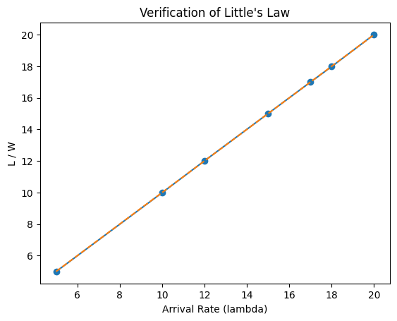
From the plot we can observe that L/W = $λ$, hence littles law holds.
Conclusion :
The effect of arrival rate on system performance was successfully analyzed using Monte Carlo simulation. Results showed that as the arrival rate (λ\lambdaλ) increases, both the average number of people in the system (LLL) and the average waiting time (WWW) increase significantly. The system remained stable for arrival rates below approximately 20 passengers per minute, while higher arrival rates caused queue growth and unstable behavior. Additionally, the results verified Little’s Law since the ratio L/WL/WL/W closely matched the arrival rate λ\lambdaλ in the stable operating region. This analysis helped identify the operational capacity limits of the airport preboarding system.

2.2. Task 2 – Optimizing number of luggage screening stations
Objective:
In this task we are investigating how the number of security screening stations (n3) affect system performance and then we will identify optimal number of servers that balances cost and efficiency
Cost Function :
Cost=h⋅L−R⋅S+c⋅n3​
Where:
- h = 1 (per person cost)
- R = 1 (reward per minute per person served)
- c = 10 (cost per security attendant)

Method:
- Ran Monte carlo simulation with 50 replications and simulation time of 3600 min.
- Fixed arrival rate at $λ$=10 per minute
- Vary n3 from 1 to 20 to obtain a range in which the system is stable.
- Find n3 value for which system is stable and cost is minimum using cost function

Observations:
n3 | Average L | Average W | Departure Rate S | Cost | Status
1 | 20302.50 | 1997.92 | 2.01 | inf | Unstable
2 | 14987.15 | 1512.22 | 3.99 | inf | Unstable
3 | 10012.17 | 1011.37 | 5.95 | inf | Unstable
4 | 5020.53 | 477.52 | 8.01 | inf | Unstable
5 | 258.52 | 19.69 | 9.97 | 288.91 | Stable
6 | 79.01 | 8.09 | 9.96 | 130.74 | Stable
7 | 79.09 | 7.89 | 9.99 | 138.61 | Stable
8 | 78.89 | 7.78 | 10.02 | 147.99 | Stable
9 | 77.65 | 7.82 | 10.05 | 157.84 | Stable
10 | 77.94 | 7.81 | 9.95 | 167.79 | Stable
11 | 77.54 | 7.80 | 9.94 | 177.84 | Stable
12 | 77.56 | 7.81 | 9.90 | 187.72 | Stable
13 | 77.78 | 7.76 | 10.06 | 197.72 | Stable
14 | 78.48 | 7.79 | 10.04 | 207.64 | Stable
15 | 77.57 | 7.75 | 9.97 | 217.54 | Stable
16 | 76.85 | 7.69 | 9.92 | 227.22 | Stable
17 | 77.09 | 7.68 | 9.95 | 237.02 | Stable
18 | 76.79 | 7.69 | 9.95 | 246.73 | Stable
19 | 76.61 | 7.67 | 9.93 | 256.95 | Stable
20 | 76.22 | 7.64 | 9.99 | 266.91 | Stable

Results:
- System stability:
  - The system is stable for $n_{3}≥5$.
- Departure rate (S):
  - S increases with n3, approaching the arrival rate $λ=10$in the stable range.
  - When n3 is too low, S < λ → queues grow.
- Cost optimization:
  - Cost decreases as n3 increases until the marginal improvement in L/S is outweighed by staffing cost.
  - Optimal n3 = 6 with minimum cost = 130.74

Conclusion:
The optimization study demonstrated the influence of the number of security screening stations () on system efficiency and operational cost. Systems with fewer than 5 security stations were unstable due to insufficient service capacity, leading to excessive queue buildup and waiting times. Increasing the number of stations improved throughput and reduced congestion; however, beyond a certain point, additional staffing increased operational cost without significant performance improvement. Based on the defined cost function, the optimal configuration was found to be , which achieved the minimum total cost while maintaining stable and efficient system operation.

Problem 3: Optimization of cargo operations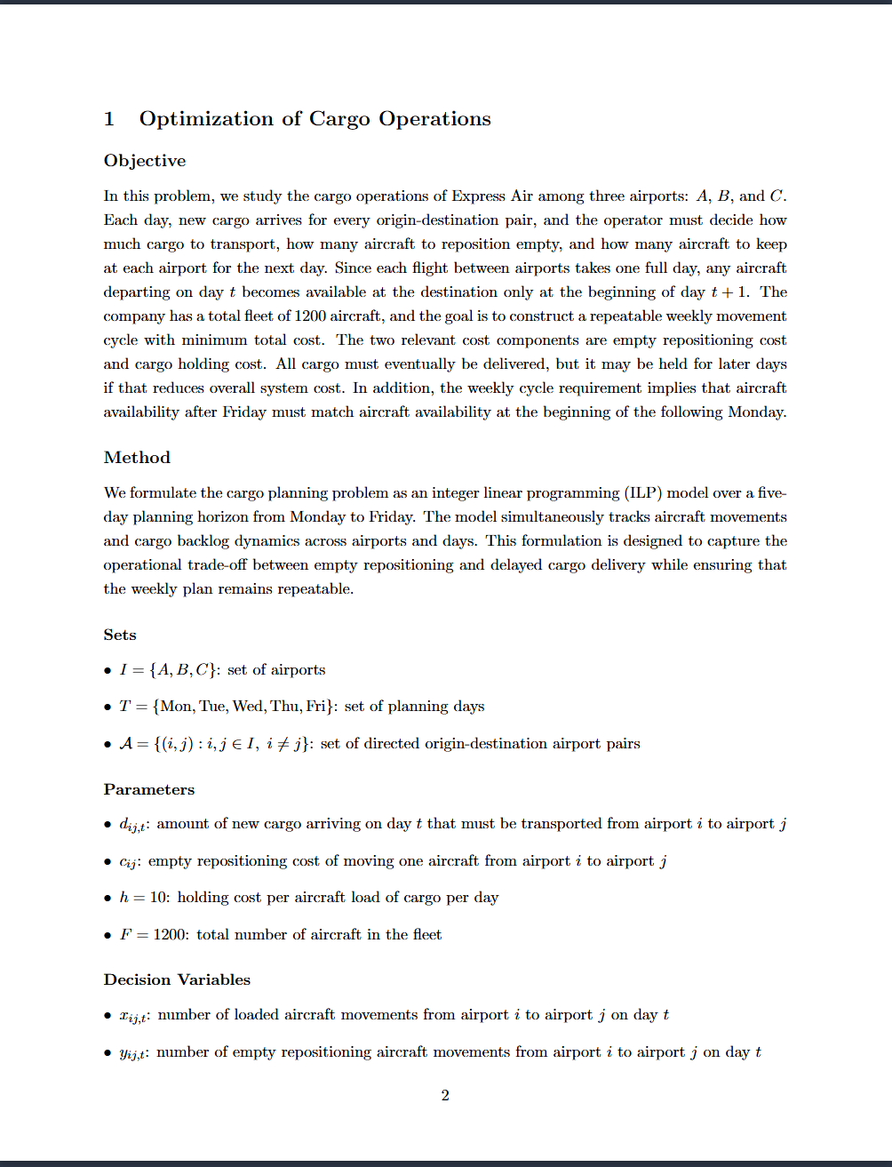
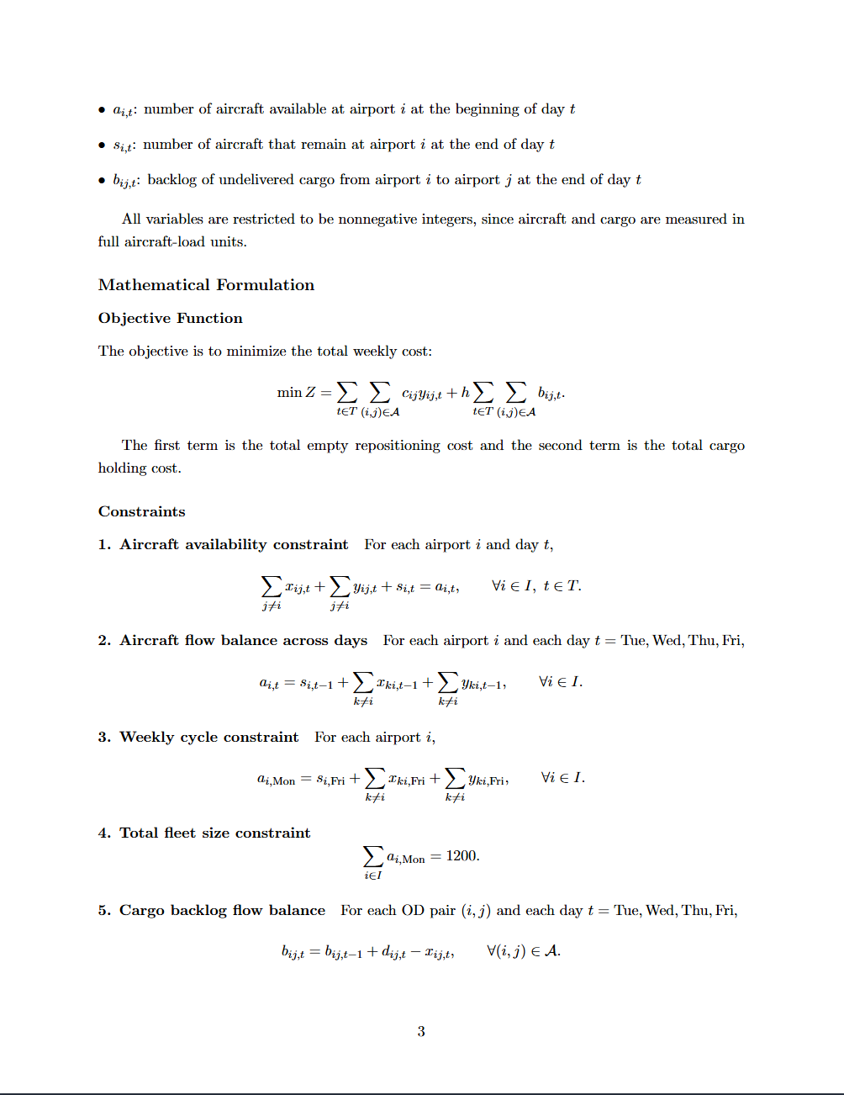

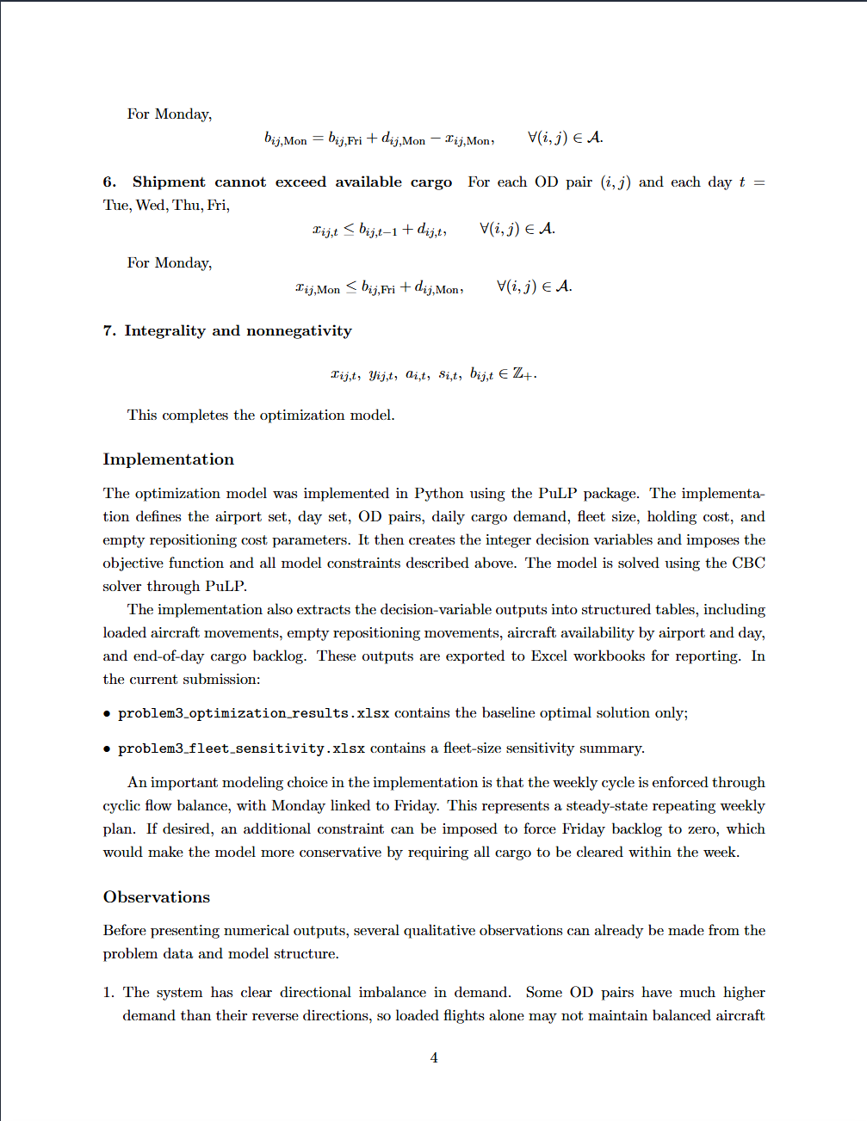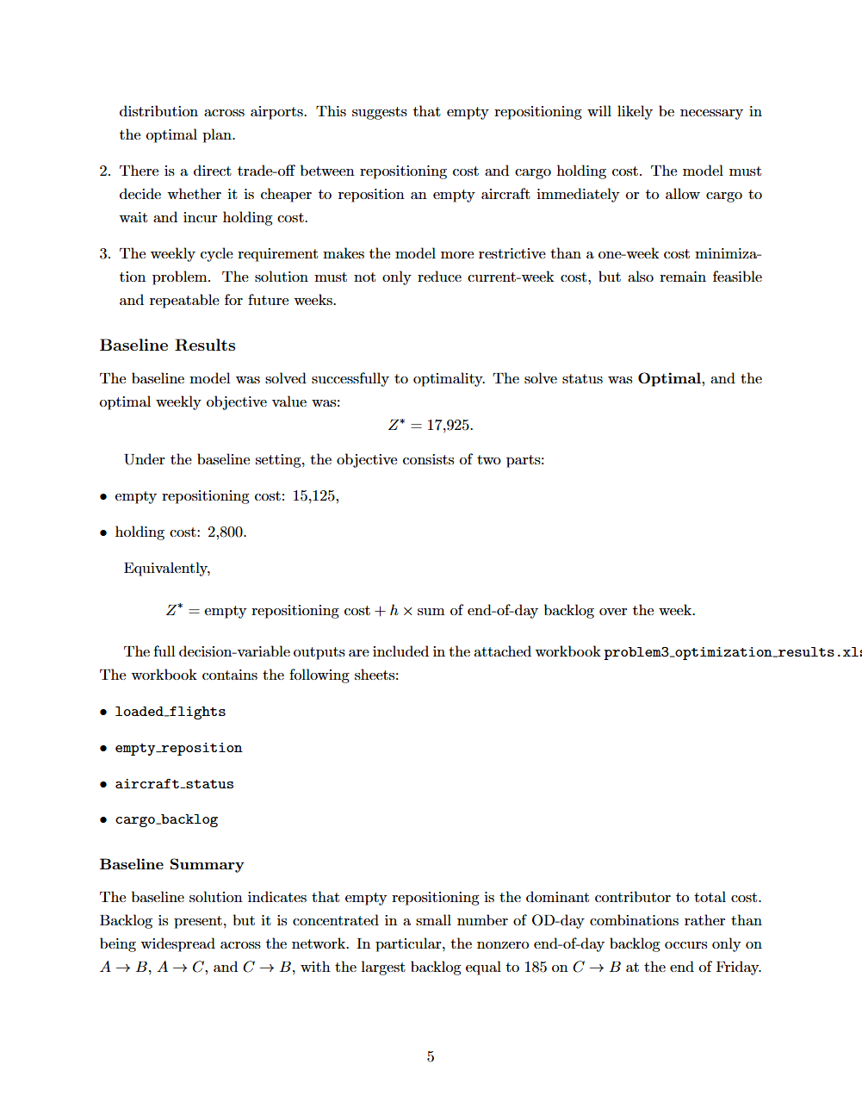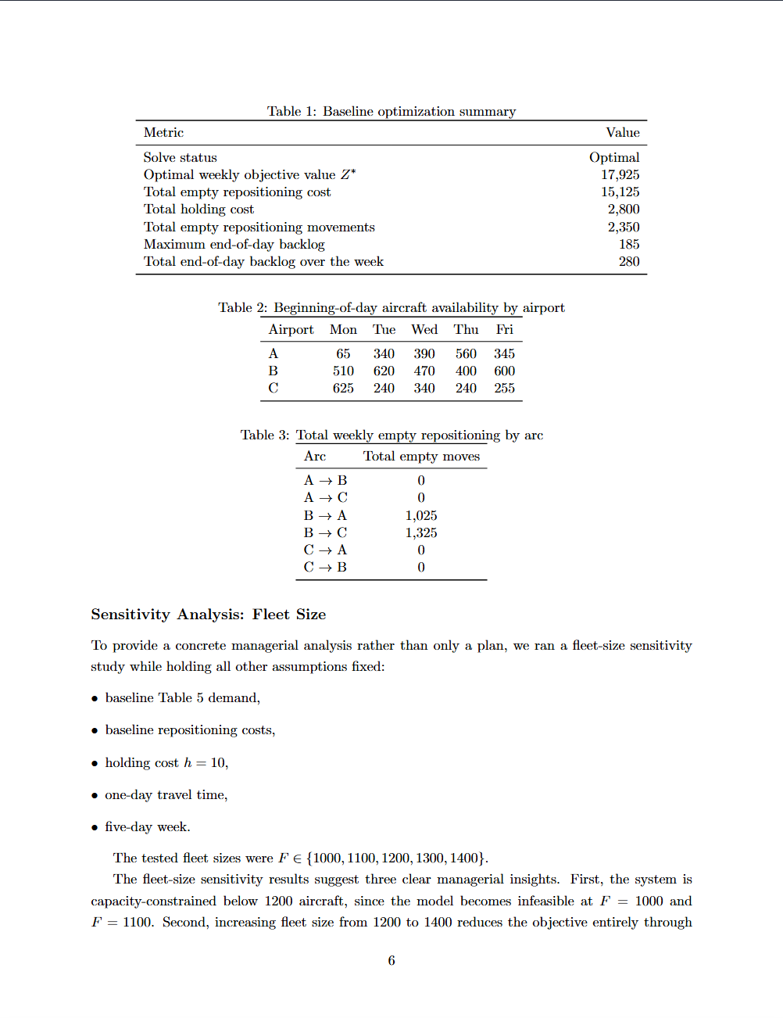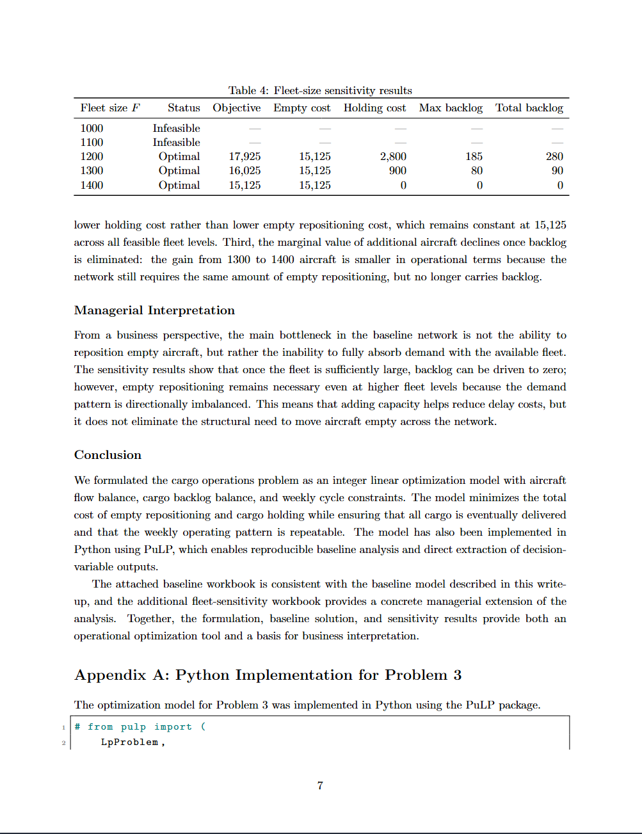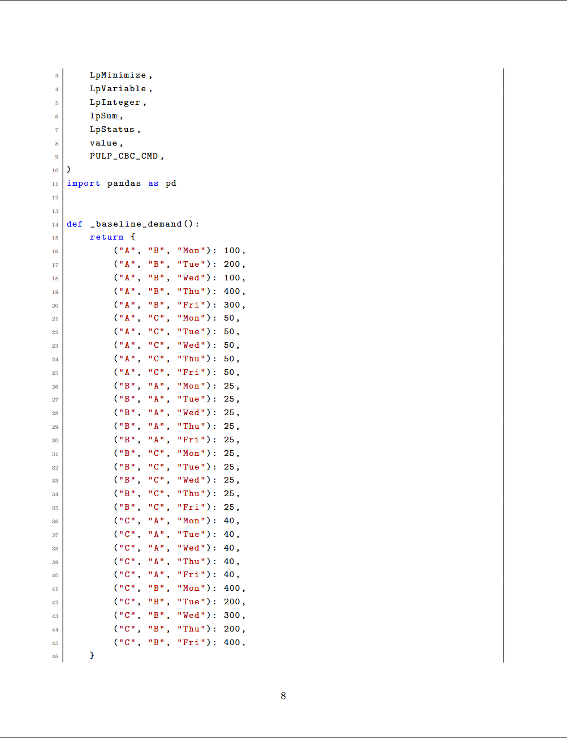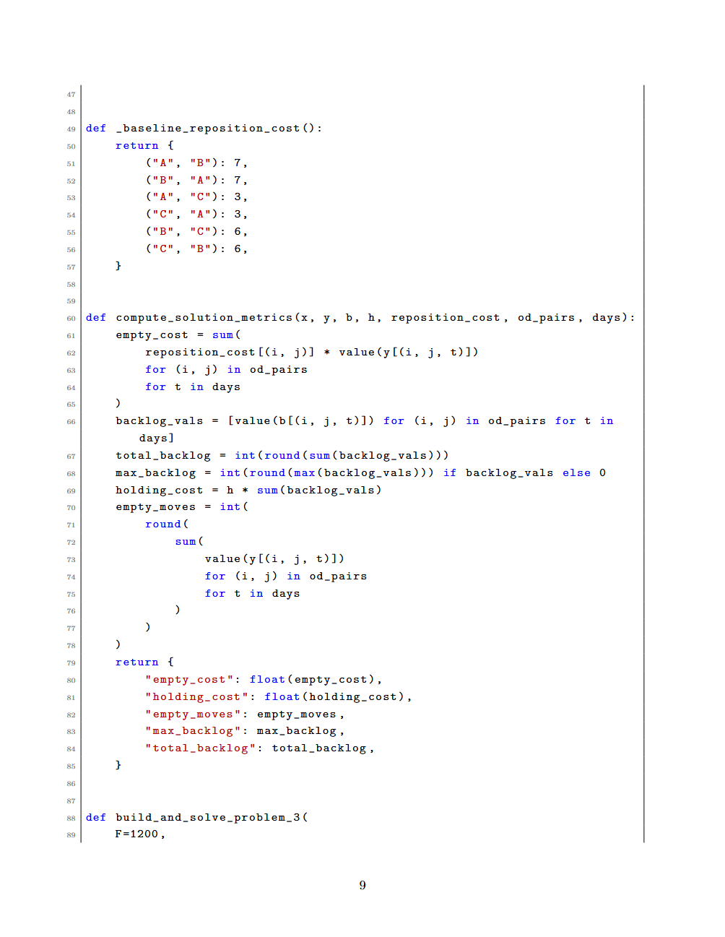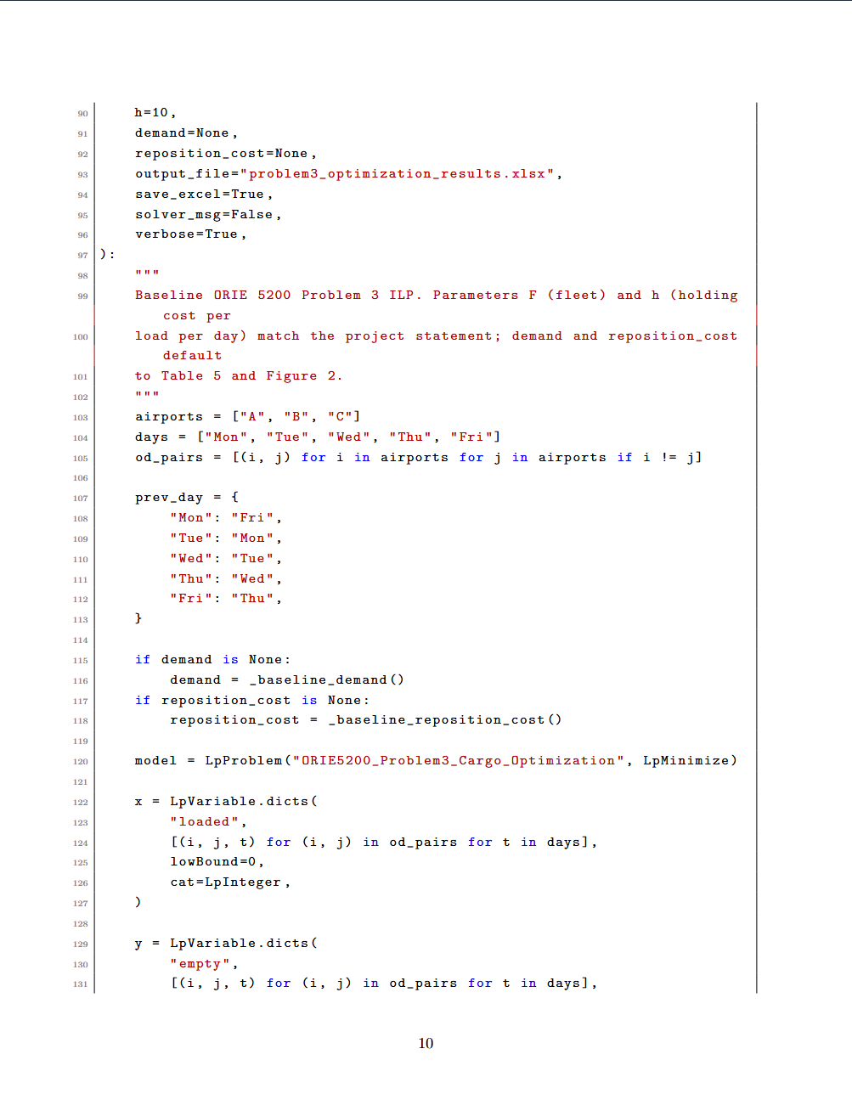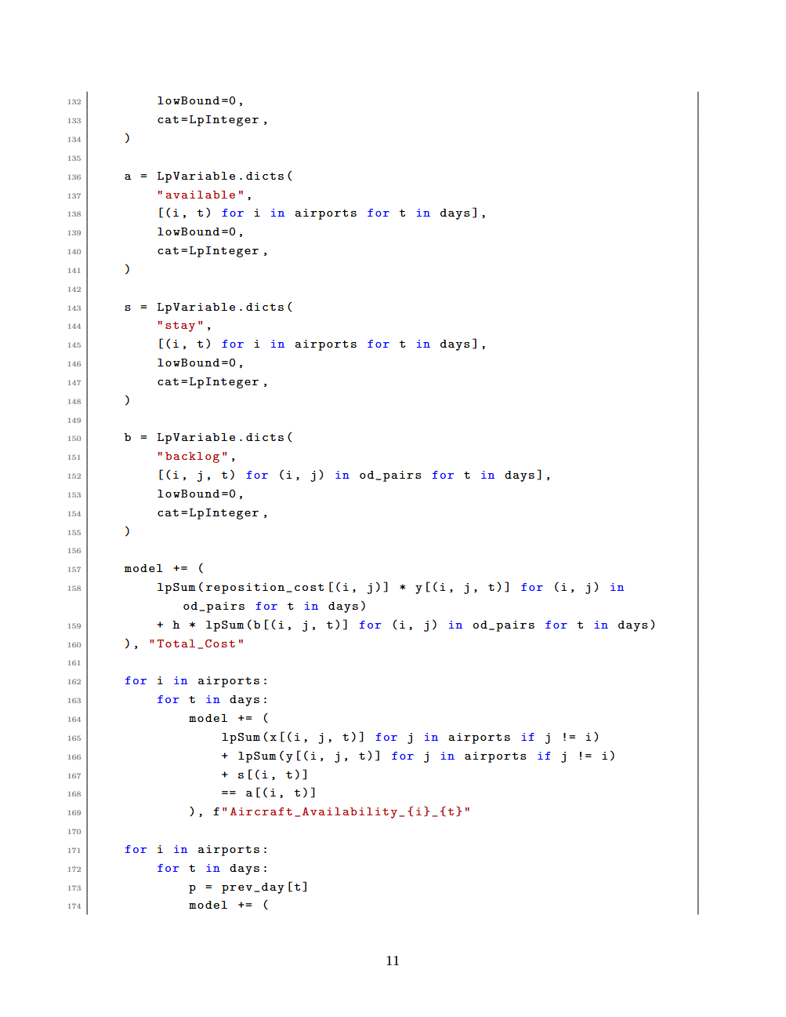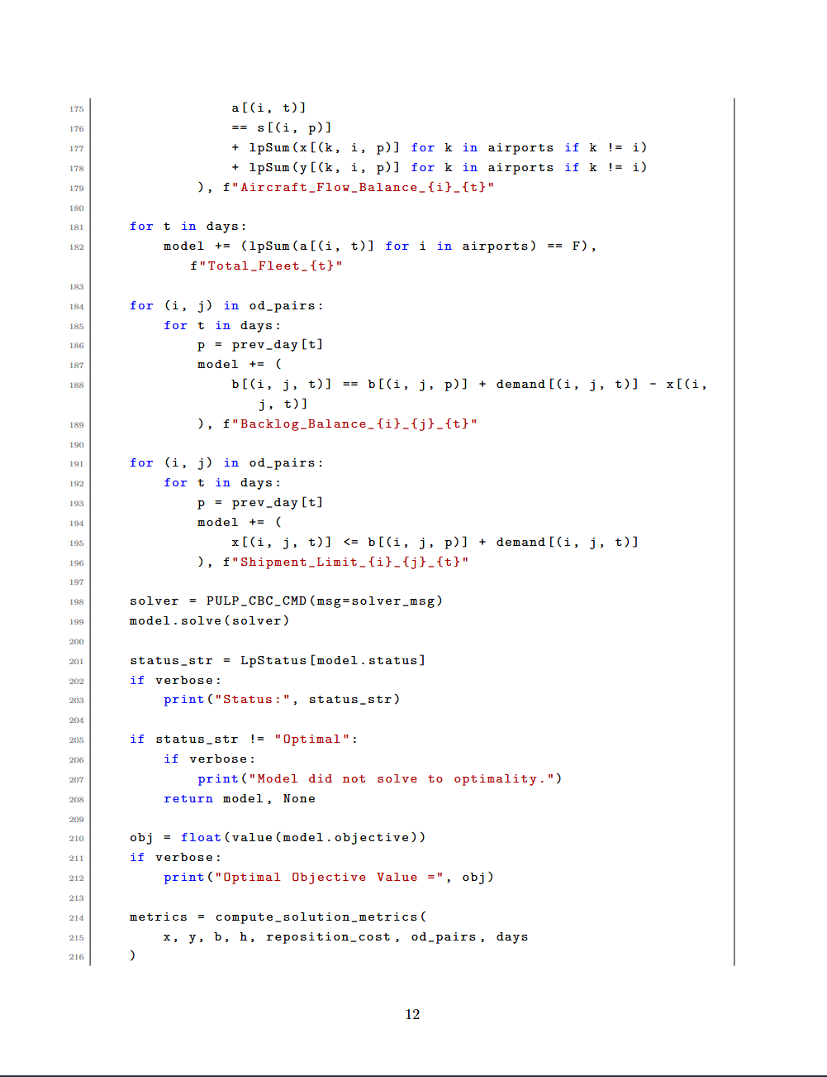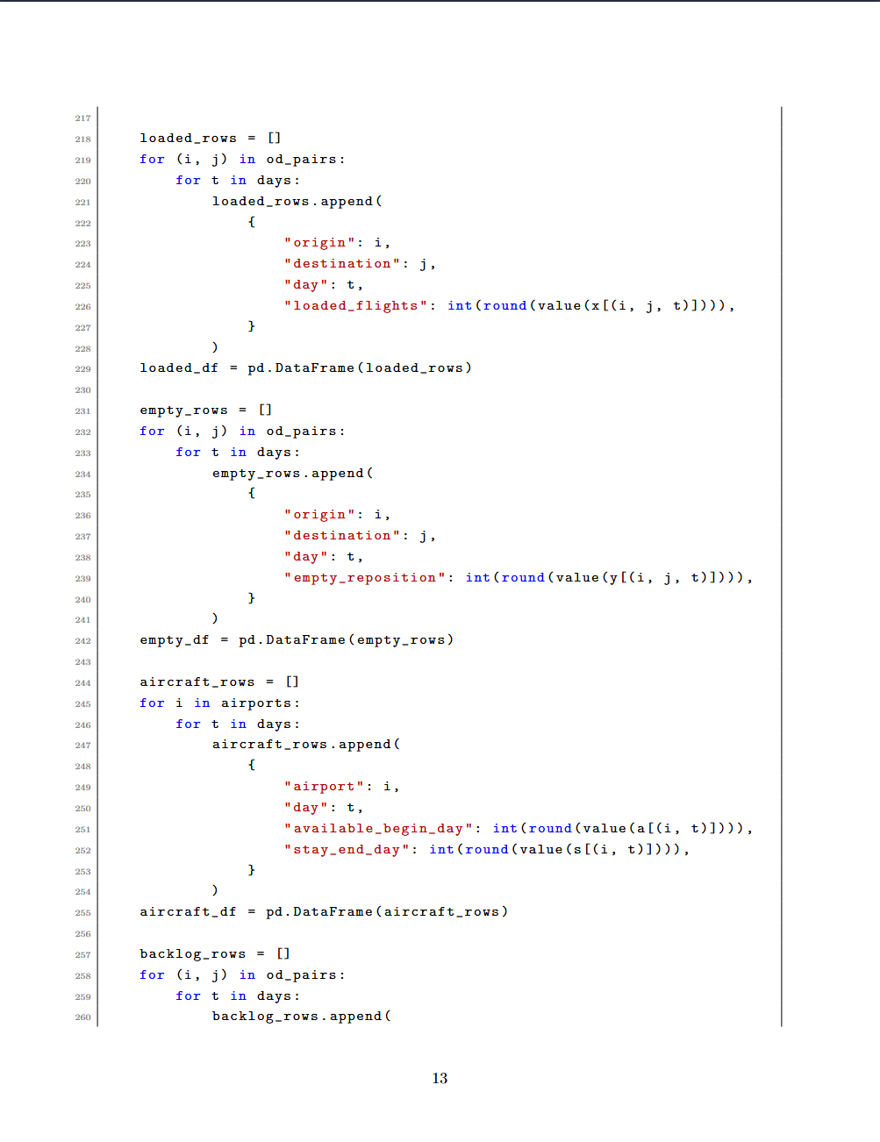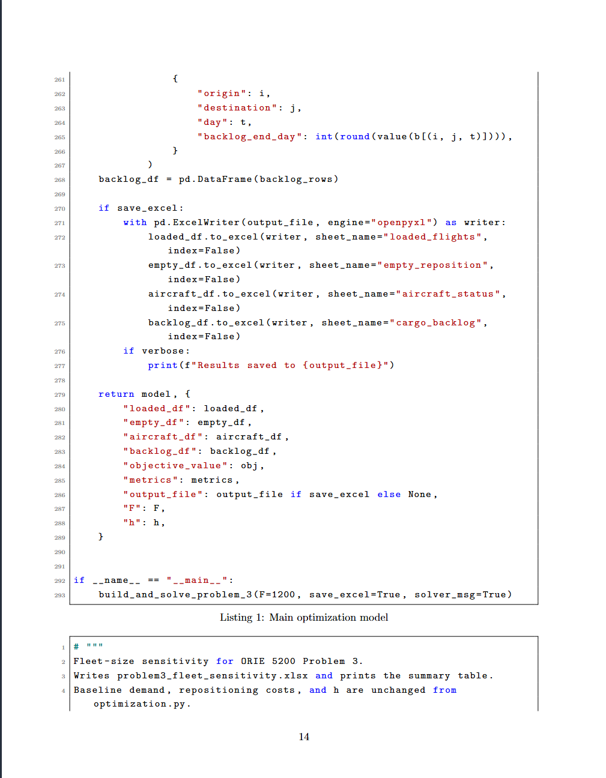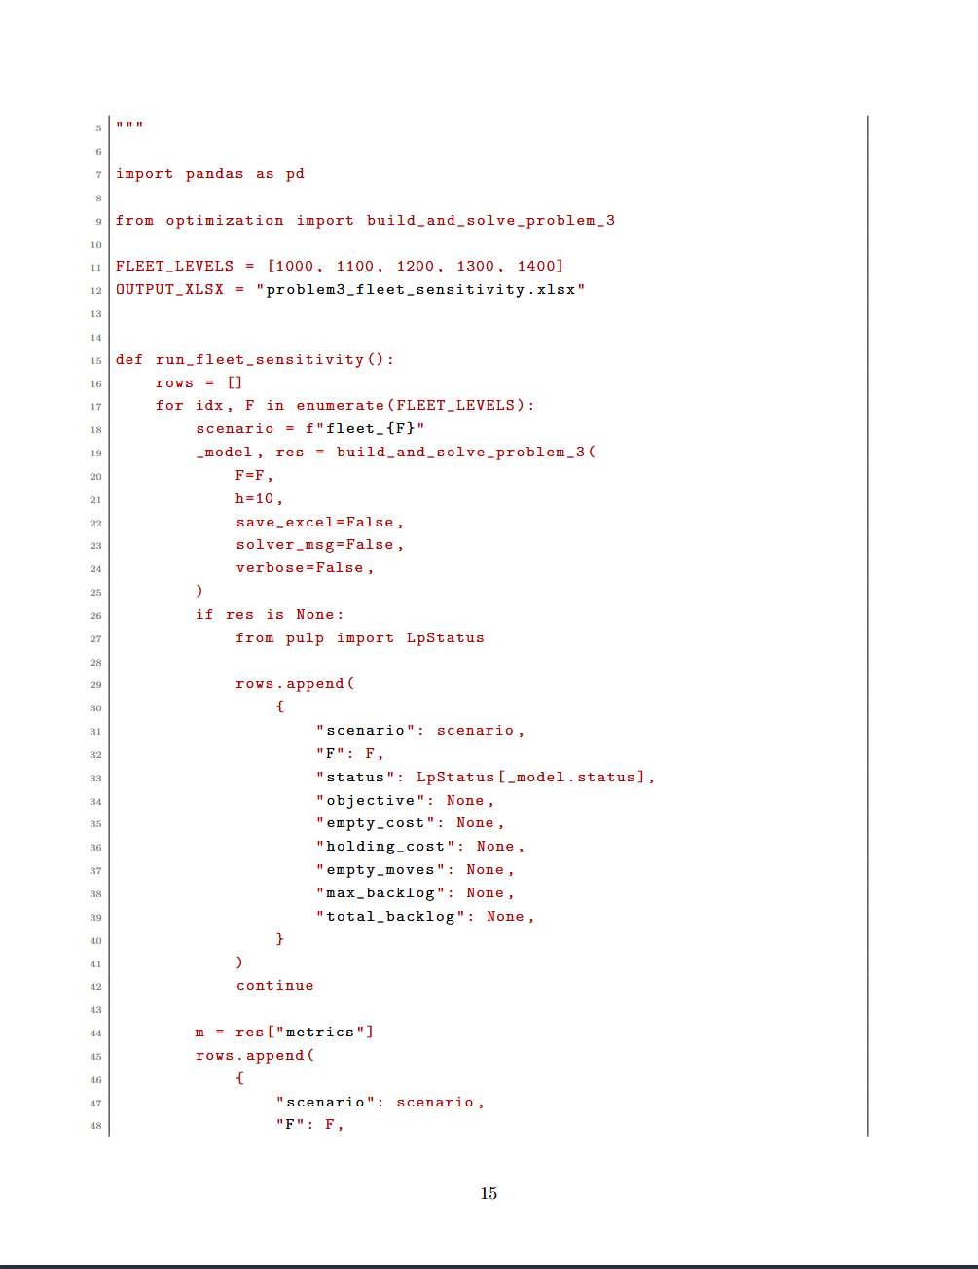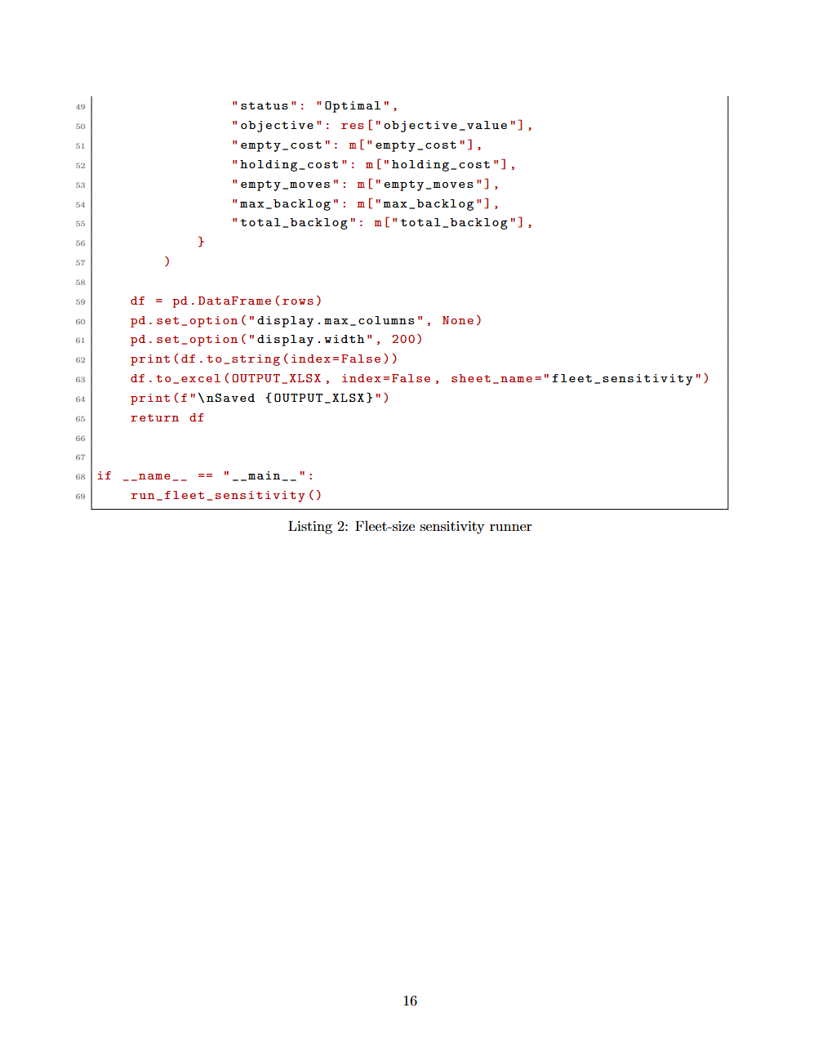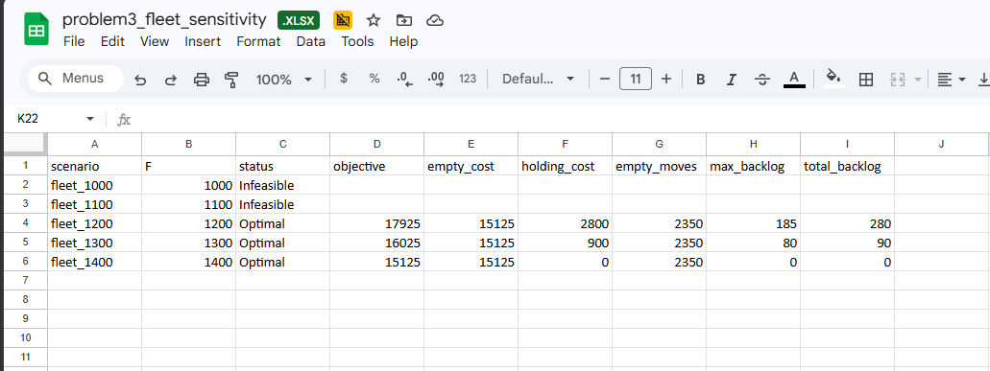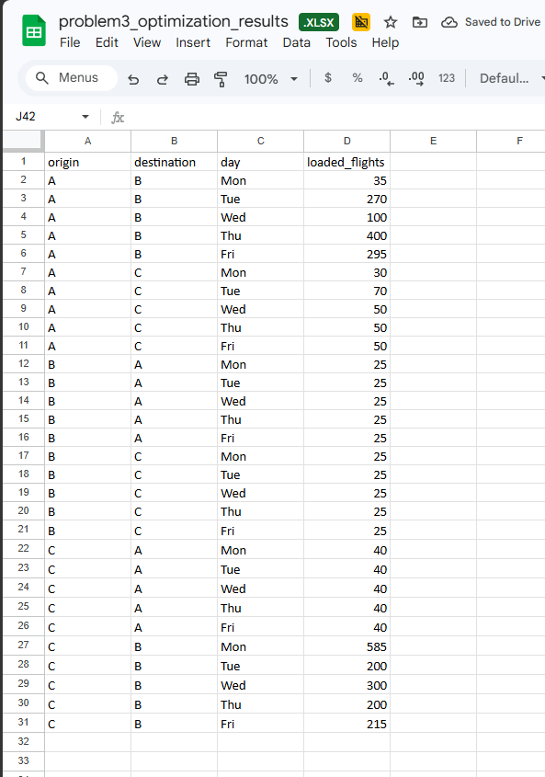

Problem 4 : Analysis of Aviation Accidents

Executive Summary Contribution for Team Report
The aviation accident data analysis shows that accident records generally declined over the 1982-2022 period, while accident severity varied strongly by weather condition and phase of flight. Landing produced the highest number of accidents, but maneuvering, climb, cruise, and approach were more likely to result in severe outcomes. The logistic regression model confirmed that IMC weather and several non-landing flight phases were strongly associated with severe accidents. Based on these findings, the recommended safety strategy is to combine frequency-based interventions for common accident phases with severity-based interventions for high-risk phases and weather conditions.
This section analyzes aviation accident records in the United States from 1982 to 2022. The objective is to identify accident trends, evaluate survival outcomes, compare risk across phases of flight and weather conditions, and fit a regression model to determine which factors are associated with severe accident outcomes. The analysis supports the broader airport operations project by connecting historical safety data with operational risk factors.

4.1 Dataset and Objective
The aviation accident dataset contains 68,565 records and 31 original columns. The main variables used in this section include event date, injury counts, aircraft damage, weather condition, broad phase of flight, purpose of flight, engine type, number of engines, and amateur-built status. The descriptive portion focuses on accident trends, survival outcomes, flight phase patterns, and weather-related severity. The regression portion estimates the probability that an accident is severe based on operational and environmental features.

4.2 Data Cleaning and Feature Engineering
The event date was parsed into a year variable. Records outside 1982-2022 or with invalid year values were excluded from year-based trend analysis, leaving 67,128 usable year records. Injury-count variables were converted to numeric form. Records with no reported people aboard were excluded from survival-rate calculations.
The survival rate was defined as:
Survival Rate = (Serious Injuries + Minor Injuries + Uninjured) / (Fatal Injuries + Serious Injuries + Minor Injuries + Uninjured)
This definition treats serious injuries, minor injuries, and uninjured occupants as survivors because the goal is to measure non-fatal outcomes. For regression analysis, the dependent variable was a binary severe accident indicator. An accident was classified as severe if it involved at least one fatal injury or if the aircraft was destroyed. Injury counts and aircraft damage were not used as explanatory variables in the model because they directly define the target variable and would create target leakage.

4.3 Descriptive Analysis
The number of aviation accident records declined over the observation period. The dataset includes 3,418 accident records in 1982 and 1,237 accident records in 2022, representing a decrease of about 63.8%. Even using the more complete recent period from 2008 to 2022, accidents declined from 1,642 to 1,237, or about 24.7%. This suggests that aviation accidents became less frequent over time, although sparse counts between 2001 and 2007 should be treated as a data limitation.
Metric | Value
Usable records after date cleaning | 67,128
Overall average survival rate | 83.0%
Fatal accident share | 18.2%
Severe accident share | 25.6%
Accident count in 1982 | 3,418
Accident count in 2022 | 1,237
Decrease from 1982 to 2022 | 63.8%
Logistic regression test AUC | 0.759
5-fold cross-validation AUC | 0.759 +/- 0.005
Table 4.1. Summary of descriptive and regression results.
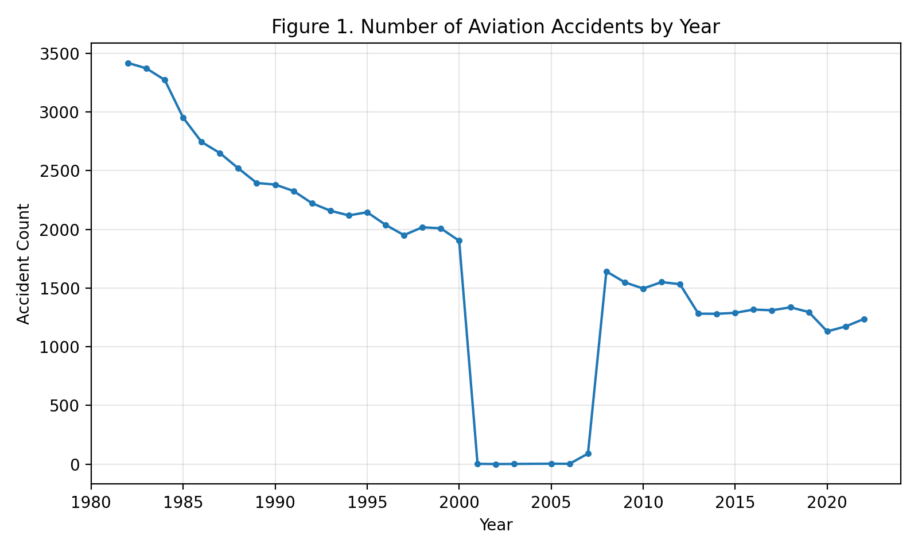
Figure 4.1. Number of aviation accidents by year.
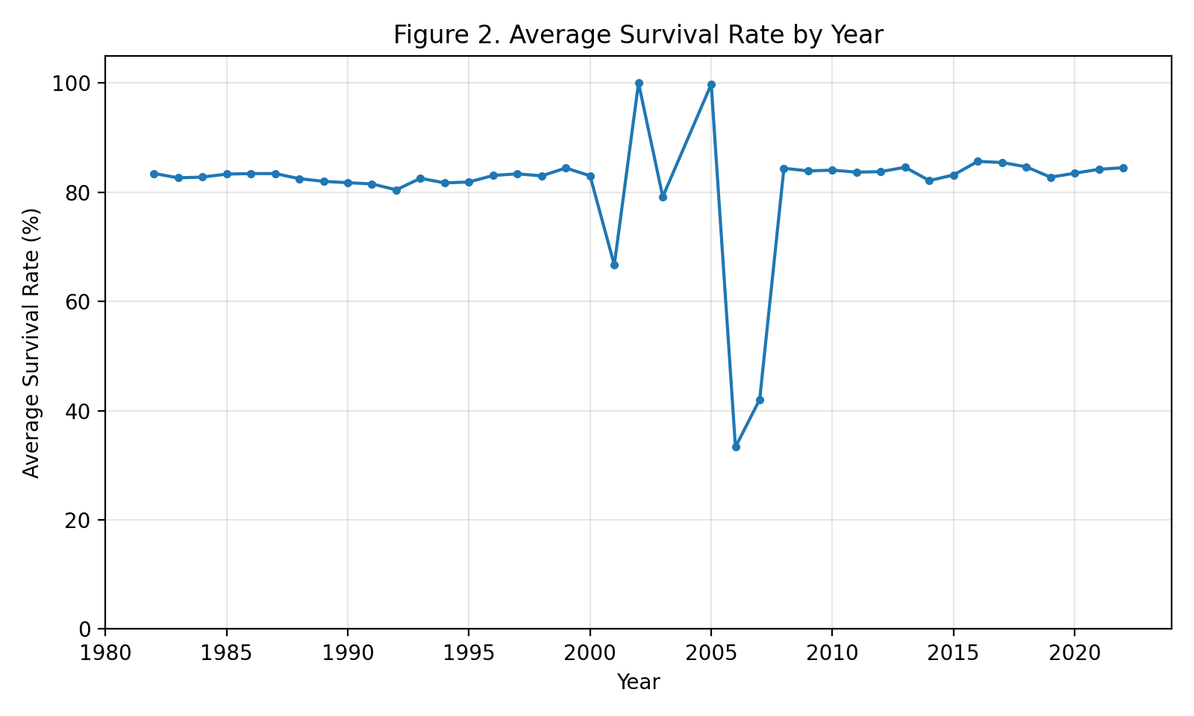
Figure 4.2. Average survival rate by year.
The overall average survival rate across records with reported occupants was approximately 83.0%. About 18.2% of accidents involved at least one fatal injury, while 25.6% were classified as severe under the fatal-injury-or-destroyed-aircraft definition. This means most accidents were survivable, but a substantial share still created serious safety consequences.
The broad phase of flight showed an important difference between accident frequency and accident severity. Landing had the largest number of accidents, with 11,423 records, followed by takeoff with 9,614 records, cruise with 7,787 records, maneuvering with 6,397 records, and approach with 4,943 records. However, landing had a relatively low severe accident rate of about 6.3%, while maneuvering had a severe accident rate of about 53.0%. This shows that accident prevention should consider both frequency and severity.
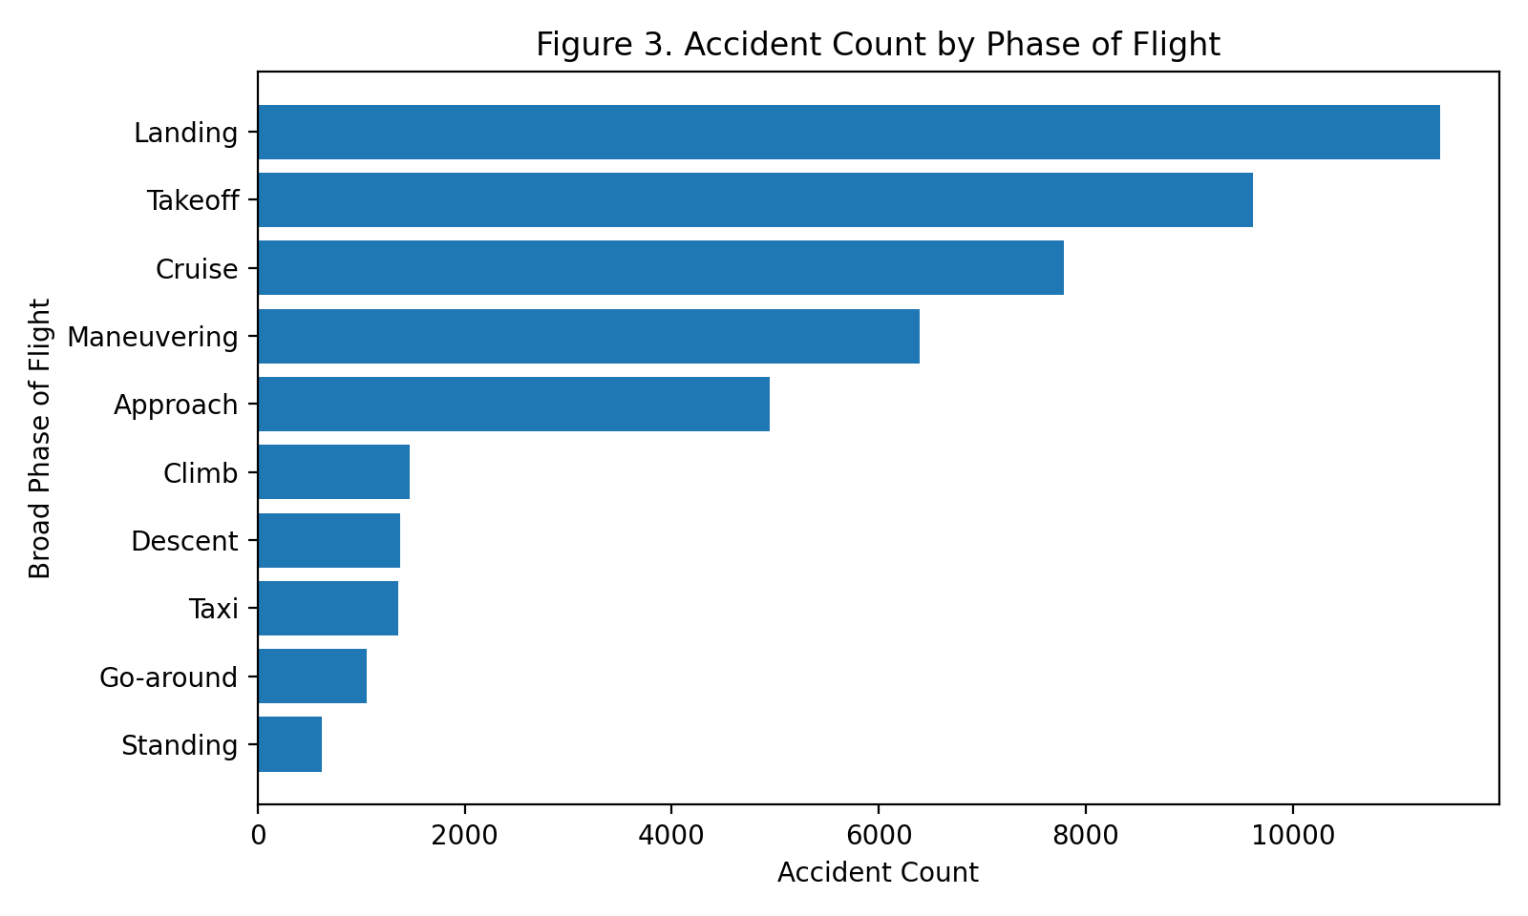
Figure 4.3. Accidents count by broad phase of flight.
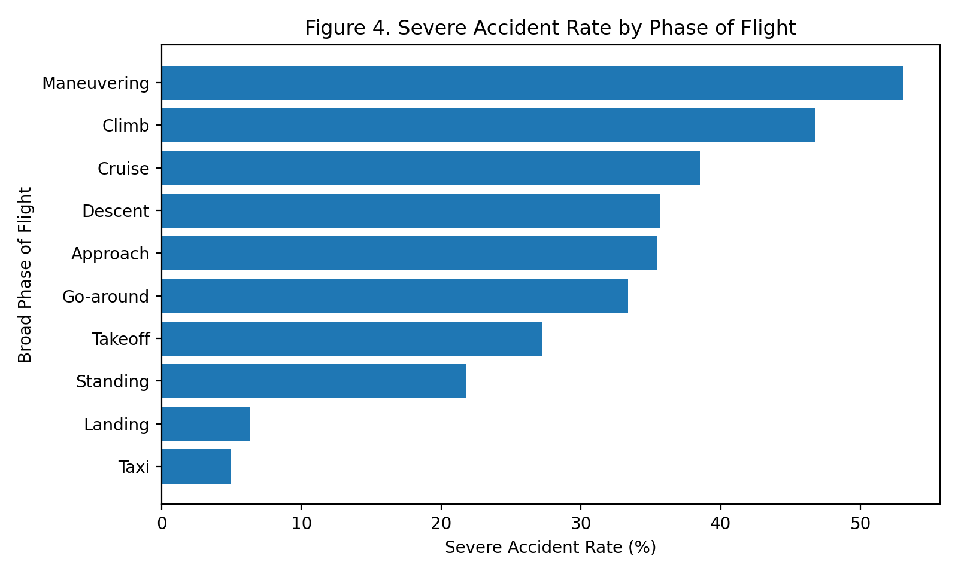
Figure 4.4. Severe accident rate by broad phase of flight.
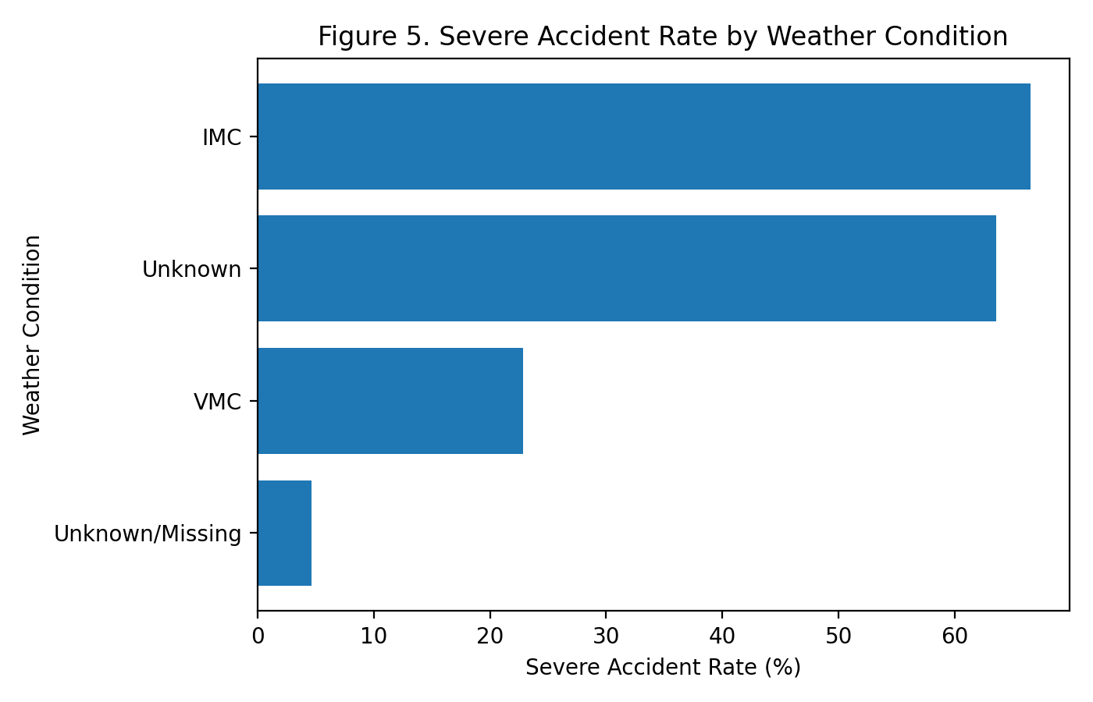
Figure 4.5. Severe accident rate by weather condition.
Weather conditions also had a strong relationship with severity. Most accidents occurred under visual meteorological conditions (VMC), but instrument meteorological conditions (IMC) had much higher fatal and severe accident rates. IMC accidents had a severe accident rate of about 66.5%, compared with about 22.8% under VMC. This indicates that lower visibility and instrument-flight conditions are associated with much more severe outcomes.

4.4 Regression Analysis
Regression model setup. The output variable for the model was severe accident, a binary variable equal to 1 if the accident involved at least one fatal injury or if the aircraft was destroyed, and 0 otherwise. The input variables were selected to describe operational and environmental conditions before using outcome information. These inputs included event year, number of engines, weather condition, broad phase of flight, amateur-built status, purpose of flight, and engine type. Categorical variables were converted into indicator variables. Landing and VMC were used as reference categories for the simplified interpretation model.
The proposed and fitted model class was logistic regression because the target variable is binary and the model provides interpretable coefficients and odds ratios. The primary loss function was binary cross-entropy, also called log loss, which penalizes incorrect predicted probabilities. For model comparison, other binary classification models could be evaluated with the same log-loss and AUC framework; however, logistic regression was used as the main report model because it balances interpretability and predictive performance.
The learned model was evaluated using a held-out train-test split and five-fold cross validation. The main evaluation metric was area under the ROC curve (AUC), since AUC measures how well the model separates severe from non-severe accidents across classification thresholds. Accuracy was also reviewed, but AUC was emphasized because the severe and non-severe classes are not perfectly balanced. The logistic regression model achieved a test AUC of 0.759. The five-fold cross-validation AUC was approximately 0.759, with a standard deviation of 0.005, suggesting moderate predictive ability and stable performance across different train-test splits.
Factor | Reference | Odds Ratio | Interpretation
IMC weather | VMC | 6.02 | Much higher odds of severe accident
Maneuvering | Landing | 17.09 | Highest severe-risk phase among major phases
Climb | Landing | 11.10 | Much higher severity than landing
Cruise | Landing | 7.26 | Higher severity despite fewer accidents than landing
Approach | Landing | 6.54 | Approach accidents are more severe than landing accidents
Takeoff | Landing | 5.47 | Higher severity than landing
Amateur-built aircraft | Non-amateur-built | 1.98 | Roughly double the odds of severe accident
Table 4.2. Key logistic regression results from the reference-category model.
The regression results support the descriptive findings. IMC weather remained a major severity factor even after controlling for flight phase and aircraft-related variables. Compared with landing, maneuvering, climb, cruise, approach, and takeoff were all associated with substantially higher odds of a severe accident. The amateur-built indicator was also associated with higher severity, suggesting that aircraft design, inspection, maintenance, or pilot familiarity may contribute to risk in this category.

4.5 Safety Recommendations
First, safety programs should focus not only on the most frequent accident phases, but also on the highest-severity phases. Landing produces the largest number of accidents, but maneuvering, climb, cruise, and approach are much more likely to result in severe outcomes. Training programs should place more emphasis on loss-of-control prevention, climb-out procedures, approach stabilization, and decision-making during maneuvering.
Second, stricter caution should be applied during IMC conditions. The descriptive analysis and regression model both show that IMC is strongly associated with severe accidents. Operators should strengthen weather-based decision support, pilot training for instrument conditions, and go/no-go decision protocols.
Third, amateur-built aircraft deserve targeted safety attention. Additional inspection guidance, pilot transition training, and maintenance documentation could reduce risk in this group. Overall, aviation safety planning should combine frequency-based thinking and consequence-based thinking: landing deserves attention because accidents are common, while maneuvering and IMC deserve attention because accidents are much more likely to be severe.

4.6 Limitations
This analysis has several limitations. First, some records have missing or incomplete values, especially for phase of flight, weather condition, and event year. Second, the dataset appears to contain sparse or incomplete records for several years between 2001 and 2007, which limits the interpretation of long-term trends. Third, the regression model identifies associations rather than causal effects. Other factors not included in the dataset, such as pilot experience, route complexity, aircraft age, maintenance quality, and reporting practices, may also affect accident severity.
Notes for Reproducibility
- Data source and scope: The analysis used the provided aviation_accident.csv file for United States aviation accident records from 1982 to 2022.Year cleaning: Event date was parsed into a year variable. Invalid dates and records outside 1982-2022 were excluded from year-based trend charts.
- Survival rate: Survival rate was calculated as non-fatal occupants divided by total reported occupants. Records with zero reported occupants were not used for survival-rate calculations.
- Severe accident target: The binary target variable was set to 1 when at least one fatal injury occurred or the aircraft was destroyed.
- Feature handling: Categorical predictors such as weather condition, broad phase of flight, purpose of flight, and engine type were one-hot encoded. Missing categorical values were coded as Missing rather than dropped.
- Target leakage control: Fatal injury counts and aircraft damage were not used as explanatory variables because they directly define the severe accident target.
- Loss function: Because the output variable is binary, logistic regression was fitted by minimizing binary cross-entropy/log loss. This loss function is appropriate for predicted probabilities of severe accidents.
- Model validation: The learned model was evaluated using a train-test split and five-fold cross validation. The main performance metric was AUC, with accuracy reviewed as a secondary metric.

Bibliography
- Cornell University SYSEN 5200 Course Notes. II_Reliability_Annotated2.pdf. Spring 2026.
- Cornell University SYSEN 5200 Course Notes. II_Reliability_Annotated3.pdf. Spring 2026.
- Cornell University SYSEN 5200 Course Notes. Monte_Carlo_Simulation_Annotated2.pdf. Spring 2026.
- Cornell University SYSEN 5200 Course Notes. III_Simulation (Discrete Events).pdf. Spring 2026.
- Cornell University SYSEN 5200 Course Notes. IV_Optimization_Introduction.pdf. Spring 2026.
- Cornell University SYSEN 5200 Course Notes. IV_Optimization_Constrained.pdf. Spring 2026.
- Cornell University SYSEN 5200 Course Notes. Regression.pdf. Spring 2026.

Appendix
Links to the code:
Problem | Link
2 | https://drive.google.com/file/d/1_CHPf4lPmPNQTsBV77ZKqlivIEDbWLSE/view?usp=sharing
3 | here
4 | https://drive.google.com/file/d/1Y8t1TH54e6jhZVL1O8_Yr-JikAp1wN3_/view?usp=drive_link

